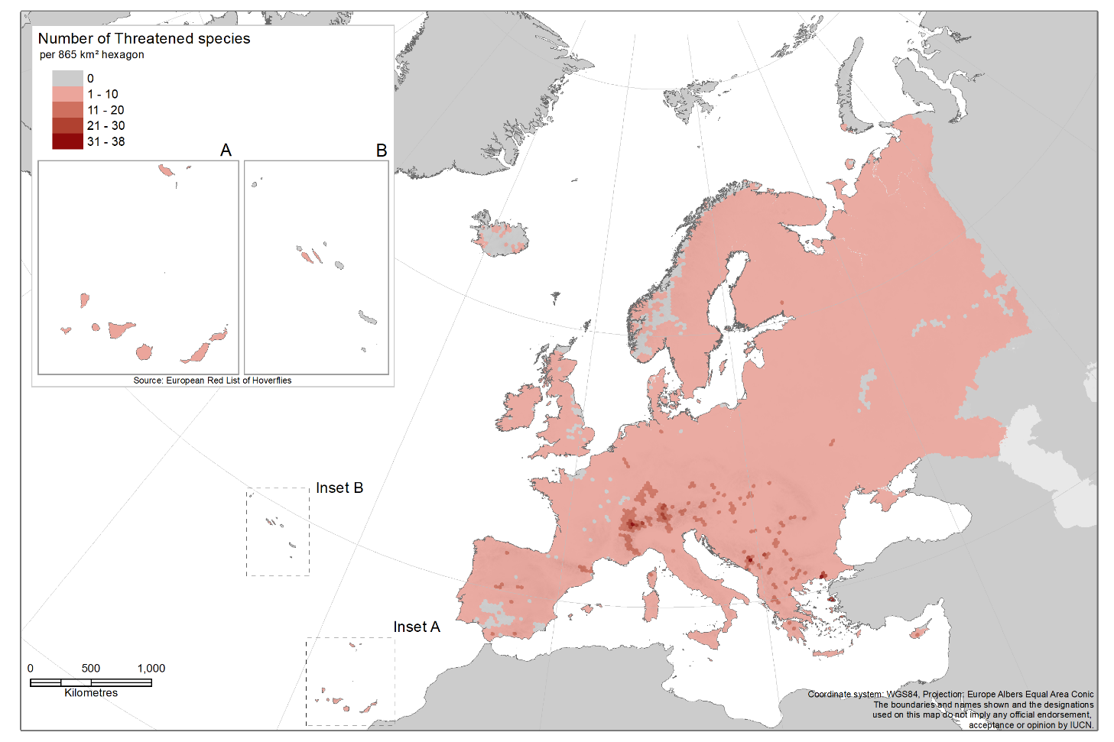
Distribution of threatened hoverfly species in Europe - darker colours indicate high concentration of threatened species.

