Jeroen van Steenis¹, Leendert-Jan van der Ent², Francis Gilbert³, Roger Morris⁴, Gerard Pennards⁵, Tsung-Hsueh (Bill) Wu⁶ & Axel M. Ssymank⁷

1 Syrphidae Foundation, Hof der Toekomst 48, 3823HX Amersfoort, The Netherlands
2 Sara Mansveltweg 19, 6874 CB, Wolfheze, The Netherlands
3 School of Life Science, Nottingham University, Nottingham NG7 2RD, United Kingdom
4 Scientific Associate of the Natural History Museum, London; c/o 241 Commonside East, Mitcham, Surrey CR4 1HB, United Kingdom
5 Zangvogelweg 124, 3815DP, Amersfoort, The Netherlands
6 National Taiwan University, Department of Entomology. No. 27, Ln. 113, Sec 4, Roosevelt road, Da’an District, Taipei City, Taiwan (R.O.C.)
7 Falkenweg 6, D-53343 Wachtberg, Germany
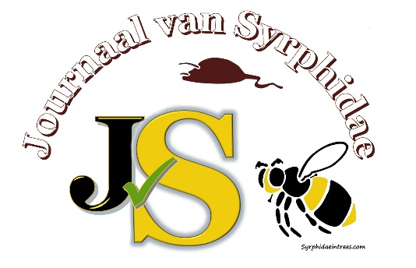
An invitation to submit articles for publication in the “Journal of Syrphidae”. This is a new and completely free electronic journal (https://www.syrphidaeintrees.com/jvs/) launched as part of the Syrphidae Foundation (https://www.syrphidaeintrees.com/syrphidae-foundation/). It will cover all aspects of worldwide Syrphid taxonomy, ecology and conservation. The articles, in English, will be published continuously and thus each article constitutes its own volume. A unique DOI number will be generated for each article and, if necessary, also registered with Zoobank to comply with the rules of the ICZN. The publications will be available at https://www.syrphidaeintrees.com/ and via Crossref (https://www.crossref.org/), ensuring that papers are appropriately archived.
For more information, or to make a donation, please visit the JvS website or send an email to: infojvs@syrphidaeintrees.com

