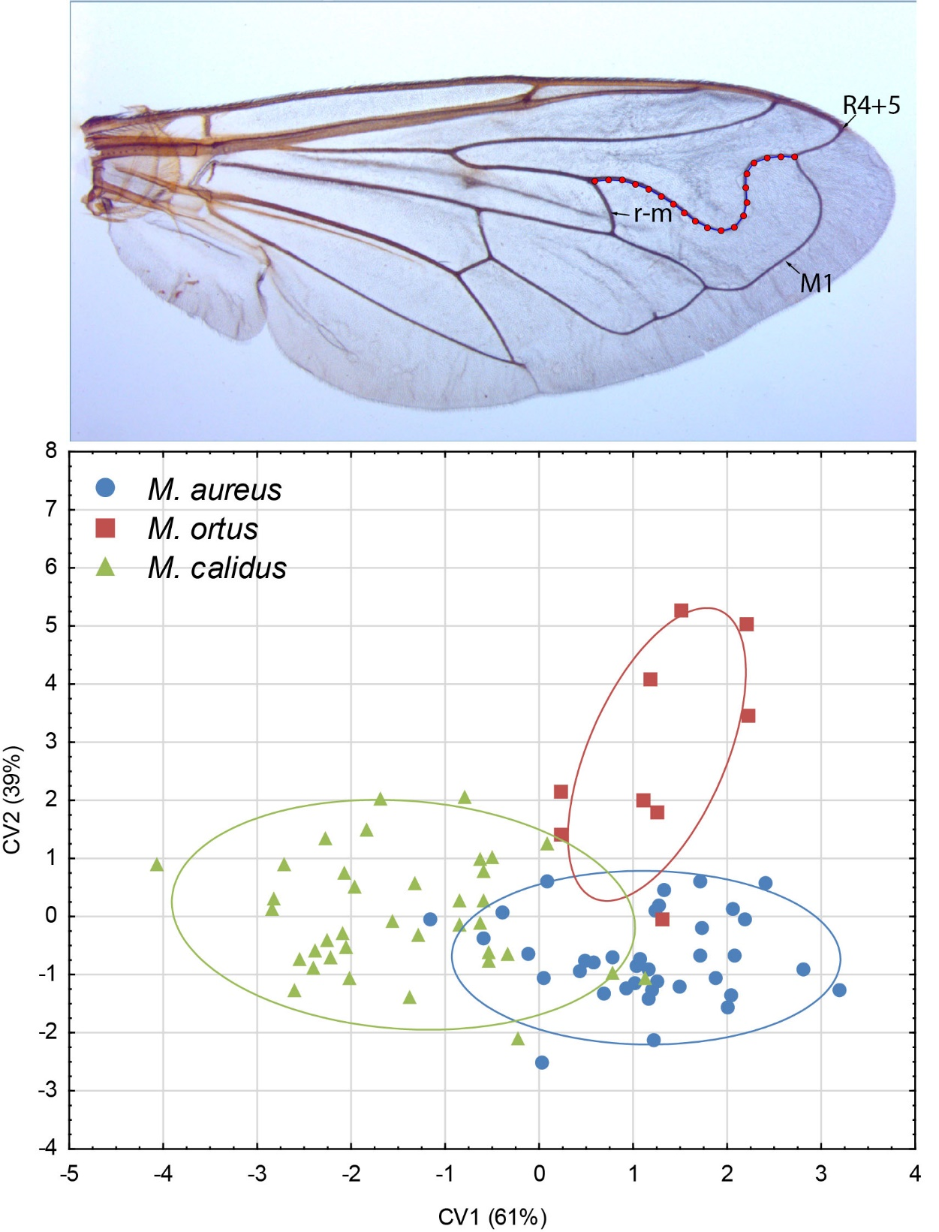
The location of 20 semilandmarks on the right wing in the Merodon aureus selected for geometric morphometric analysis and scatter plot of individual scores of CV1 and CV2 showing differences among Merodon aureus, M. calidus and M. ortus in R4+5 vein sinuation.

